**HURRICANE**

**GRAPHICAL USER INTERFACE DESIGN DOCUMENT**

**User Interface/Report Number: Login page for customers, restaurants and couriers.**

**Related Use-Case: 1, 2**



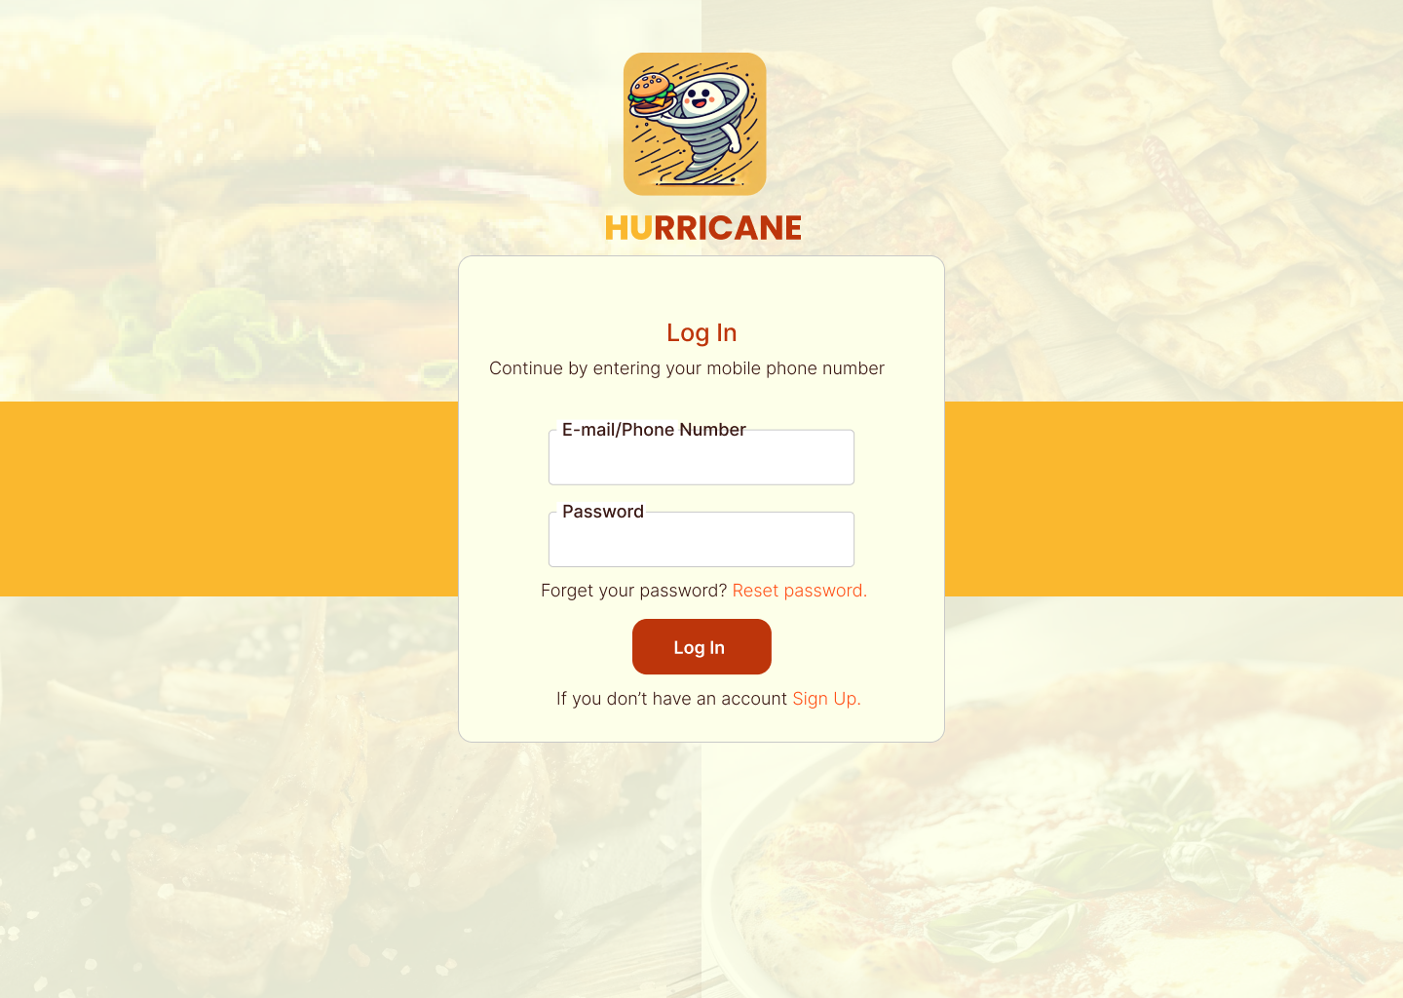

**User Interface/Report Number: Sign up page for customers.**

**Related Use-Case: 1**



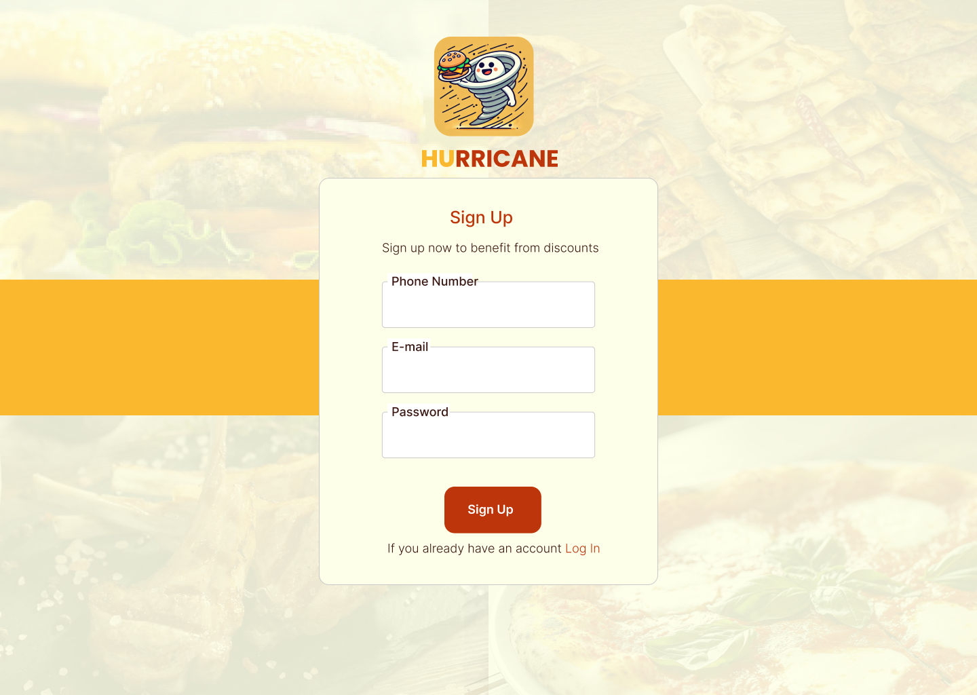

**User Interface/Report Number: Log in page for admin**

**Related Use-Case: 1, 2**



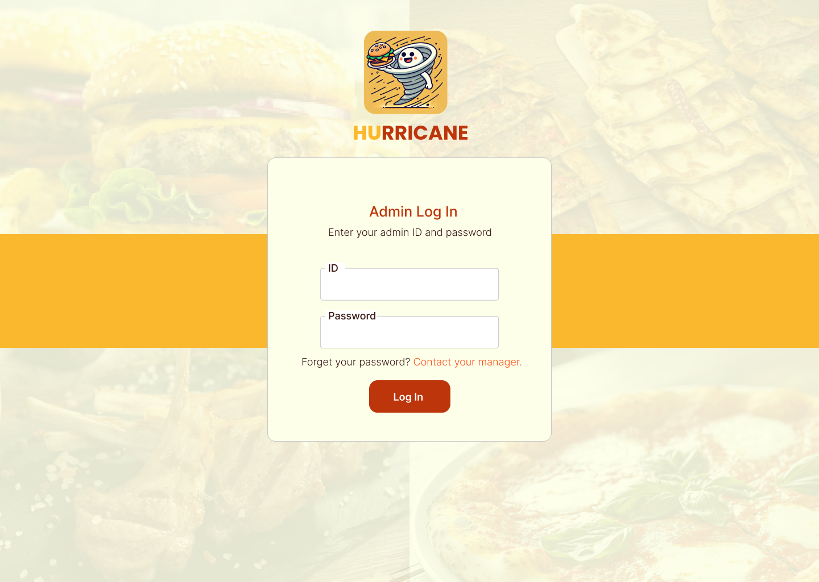

**User Interface/Report Number: Customers - Home Screen**

**Related Use-Case: 3, 12, 13**



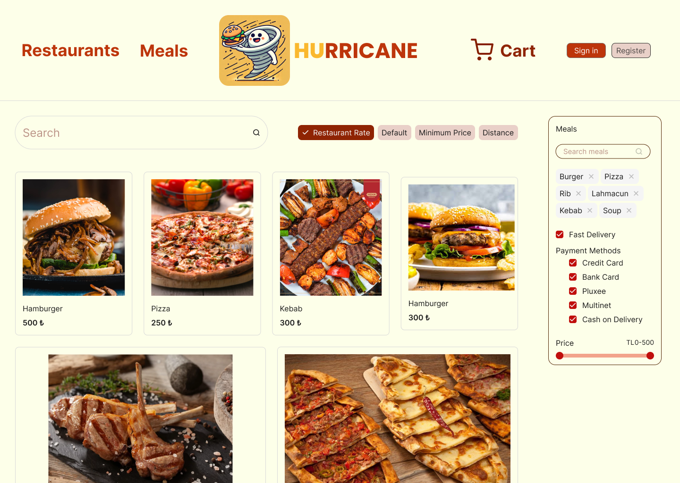

**User Interface/Report Number: Customers - Restaurant Menu Page**

**Related Use-Case: 3, 12, 13, 15**



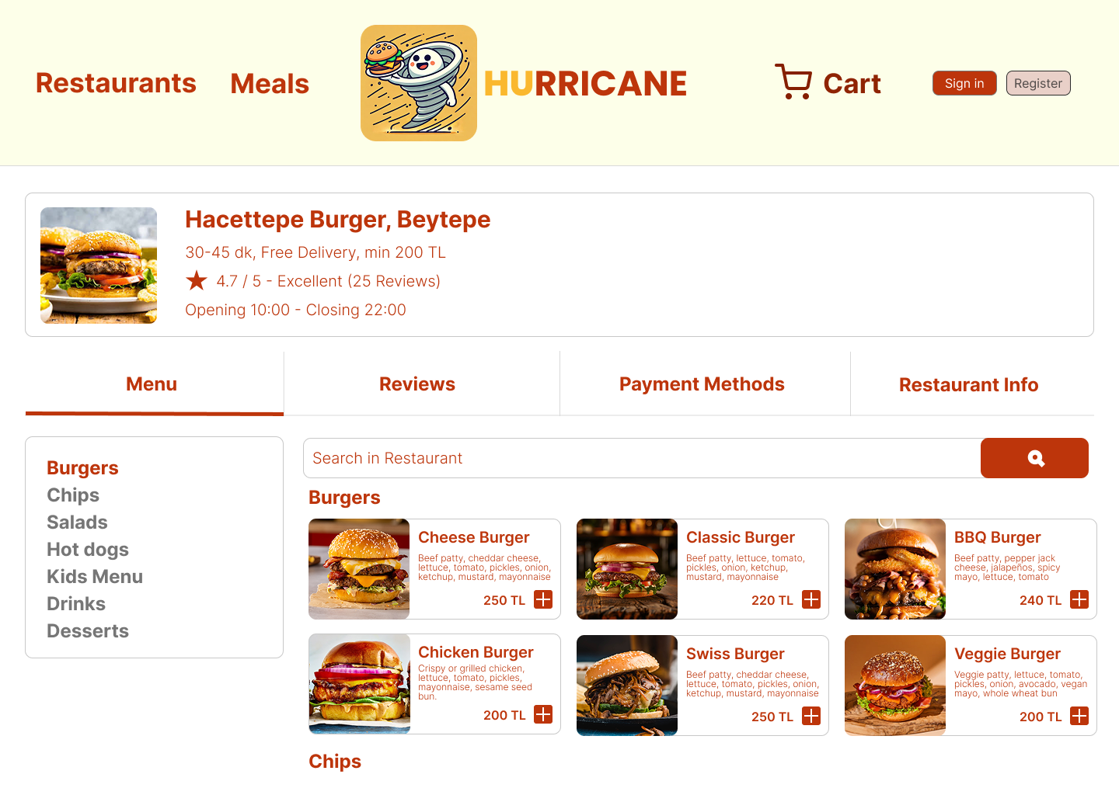

**User Interface/Report Number: Customers - Payment Page**

**Related Use-Case: 3, 5, 6**



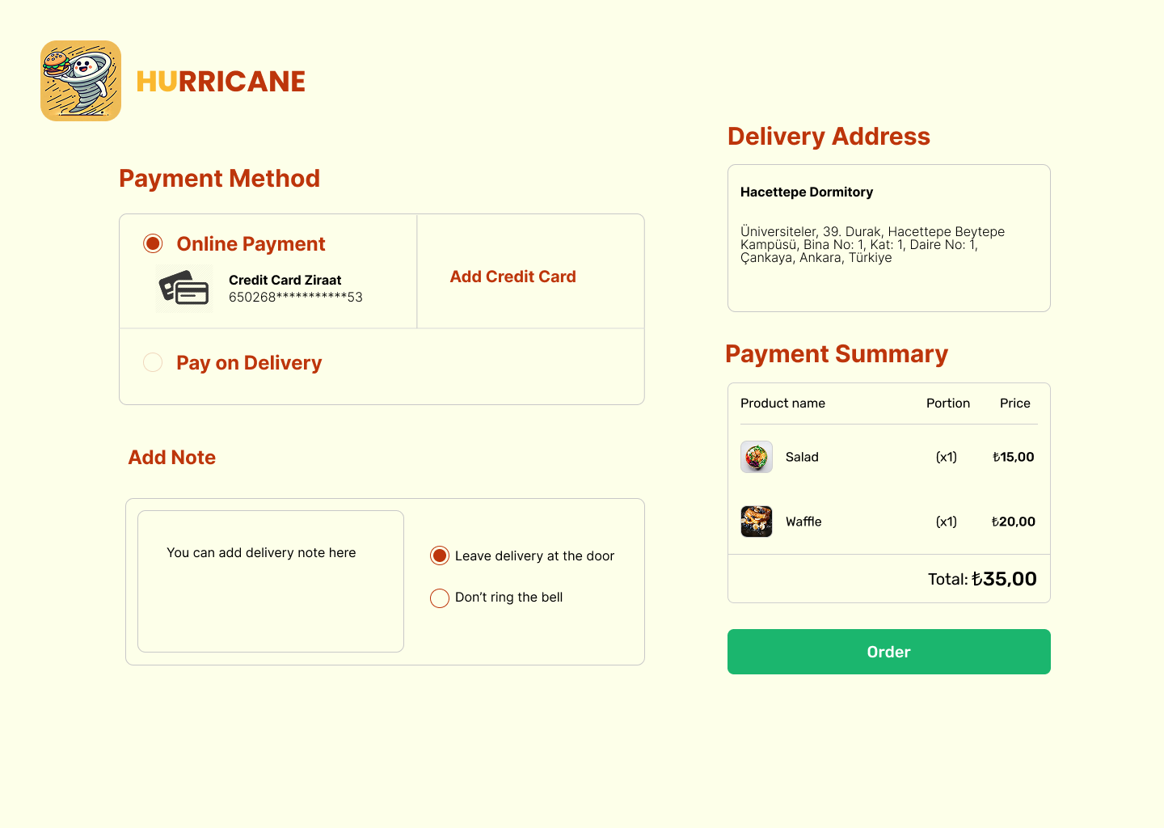

**User Interface/Report Number: Customers - Account Management Page**

**Related Use-Case: 9, 10, 18, 22**

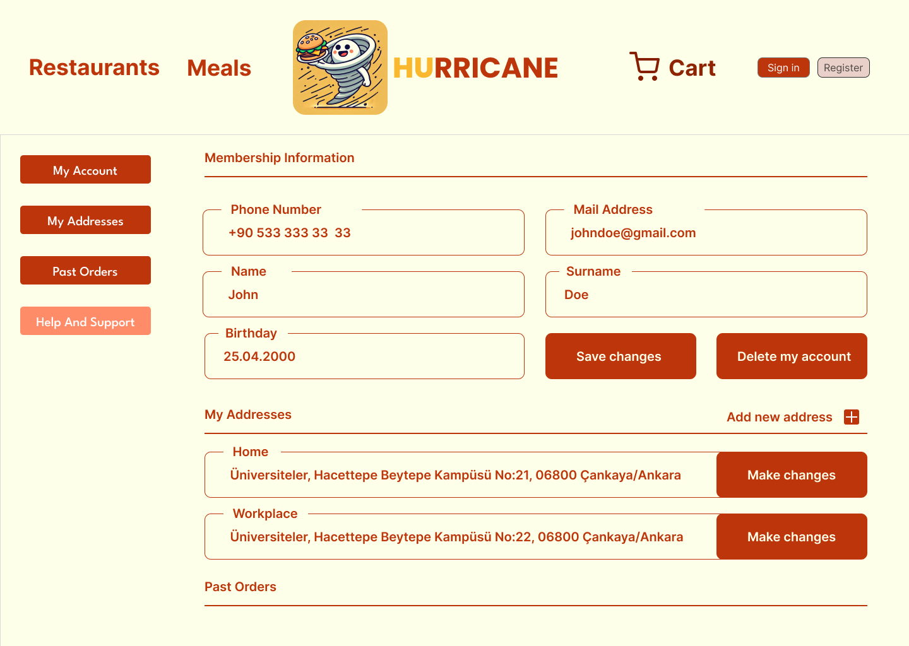

**User Interface/Report Number: Restaurant - Menu Management Page**

**Related Use-Case: 4**



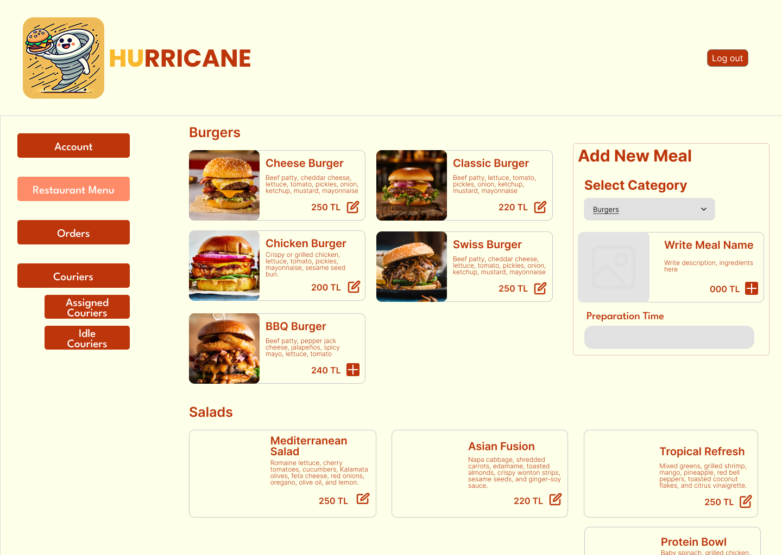

**User Interface/Report Number: Restaurant - Orders Page**

**Related Use-Case: 3, 20**



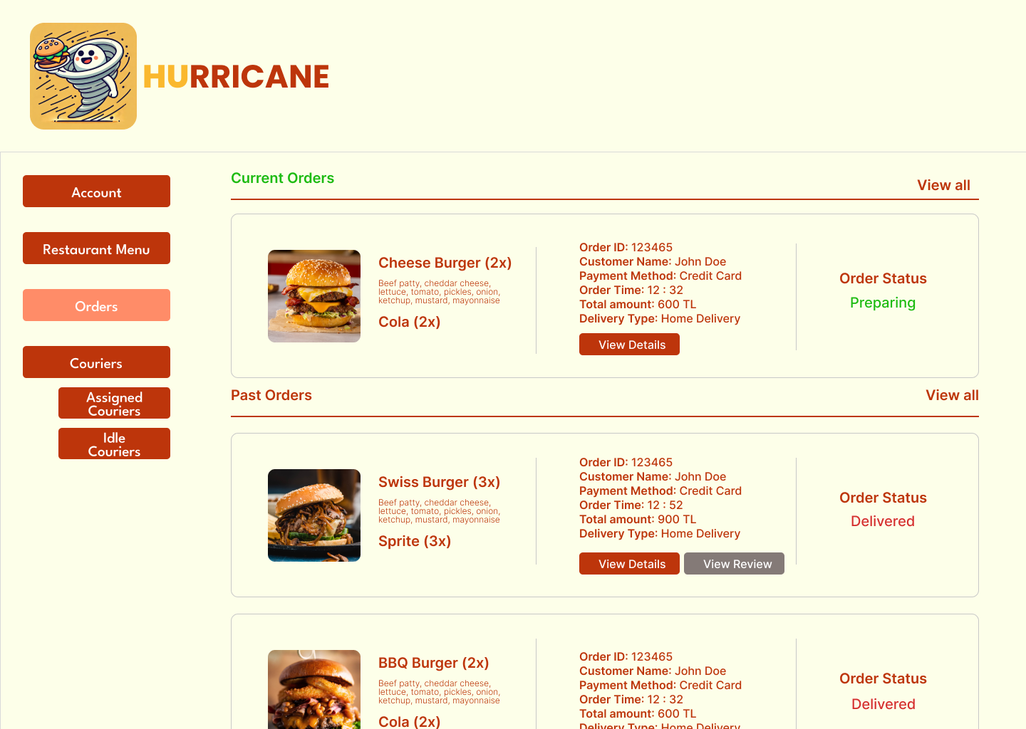

**User Interface/Report Number: Restaurant - Courier Management Page**

**Related Use-Case: 21**



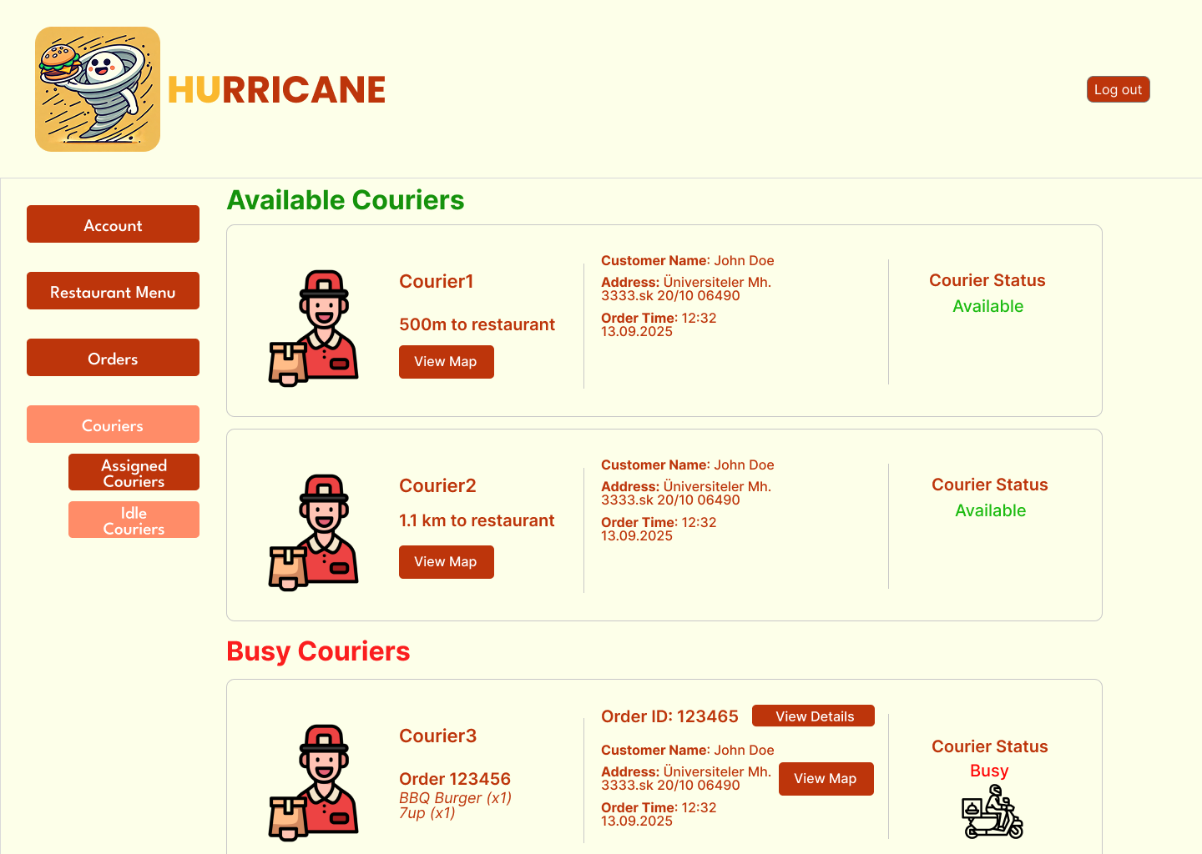

**User Interface/Report Number: Restaurant - Courier Management Page**

**Related Use-Case: 21**

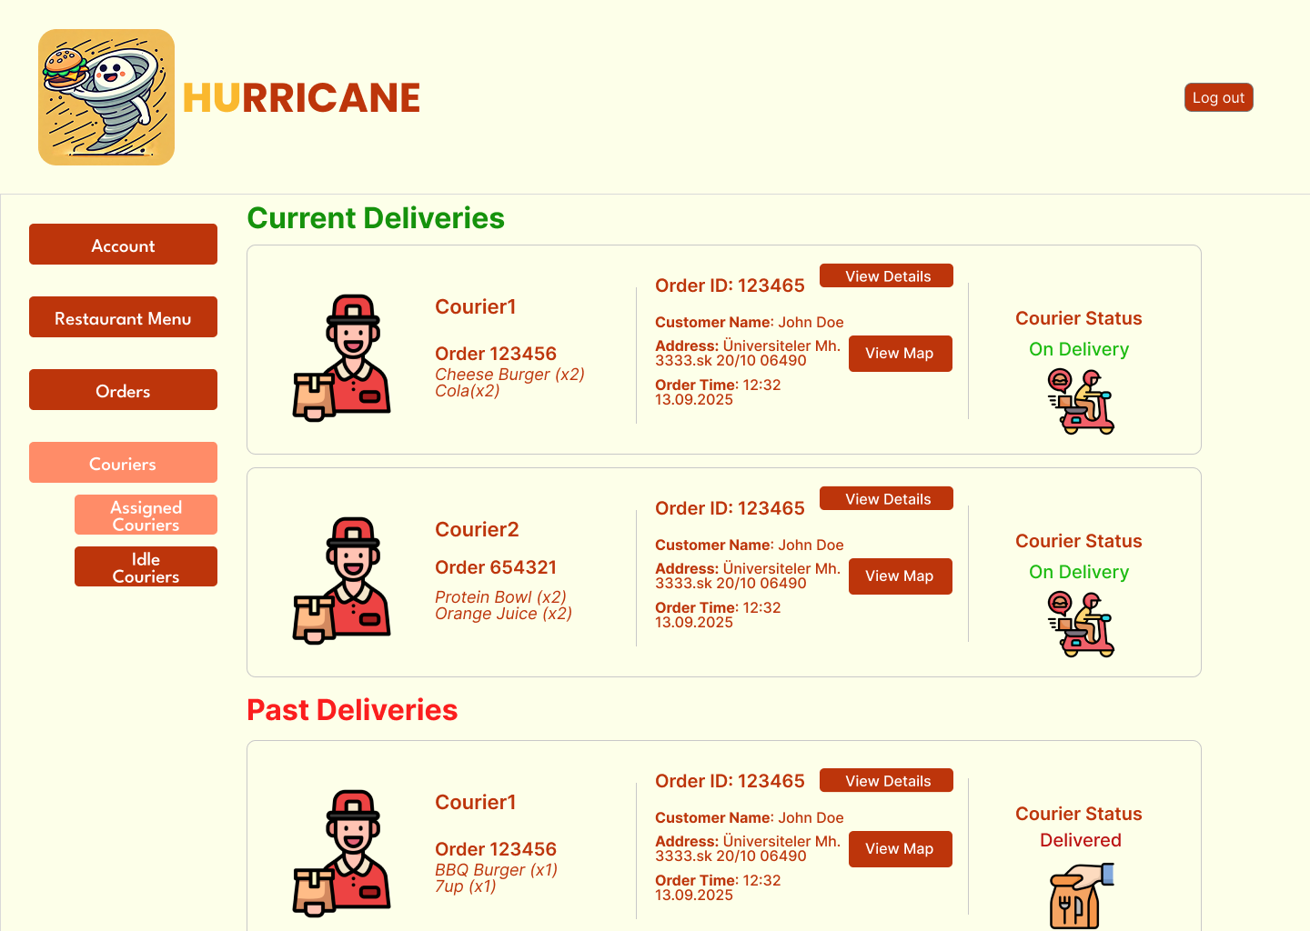

**User Interface/Report Number: Restaurant - Account Management Page**

**Related Use-Case: 14**

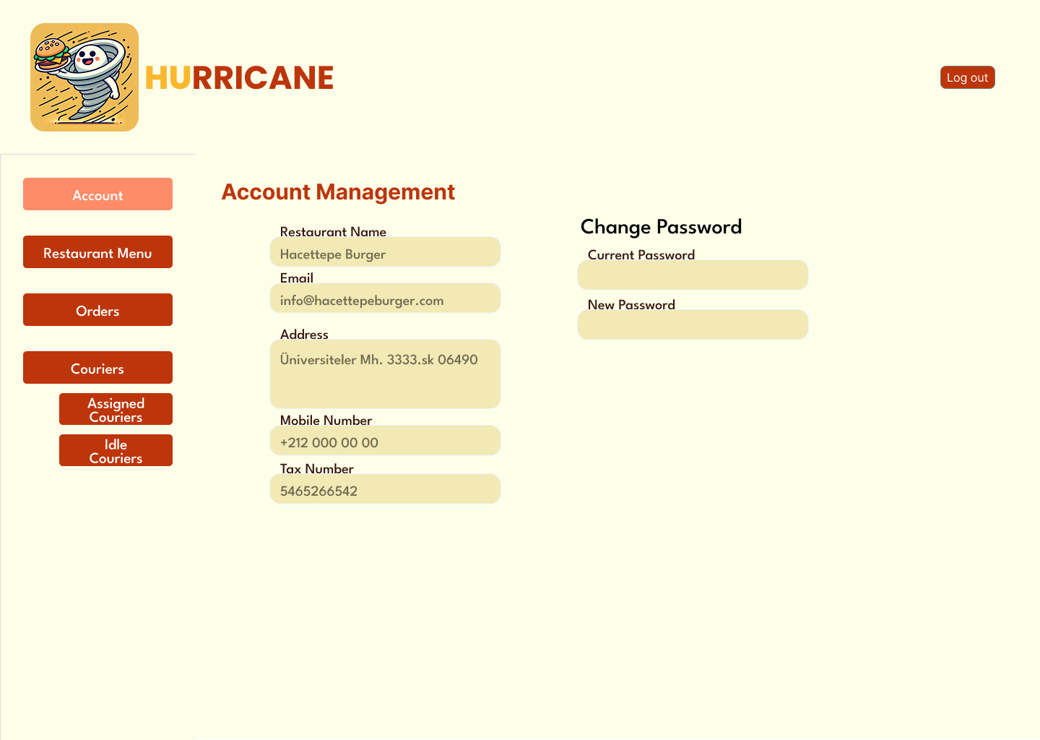

**User Interface/Report Number: Courier - Assigned Orders**

**Related Use-Case: 11, 24**



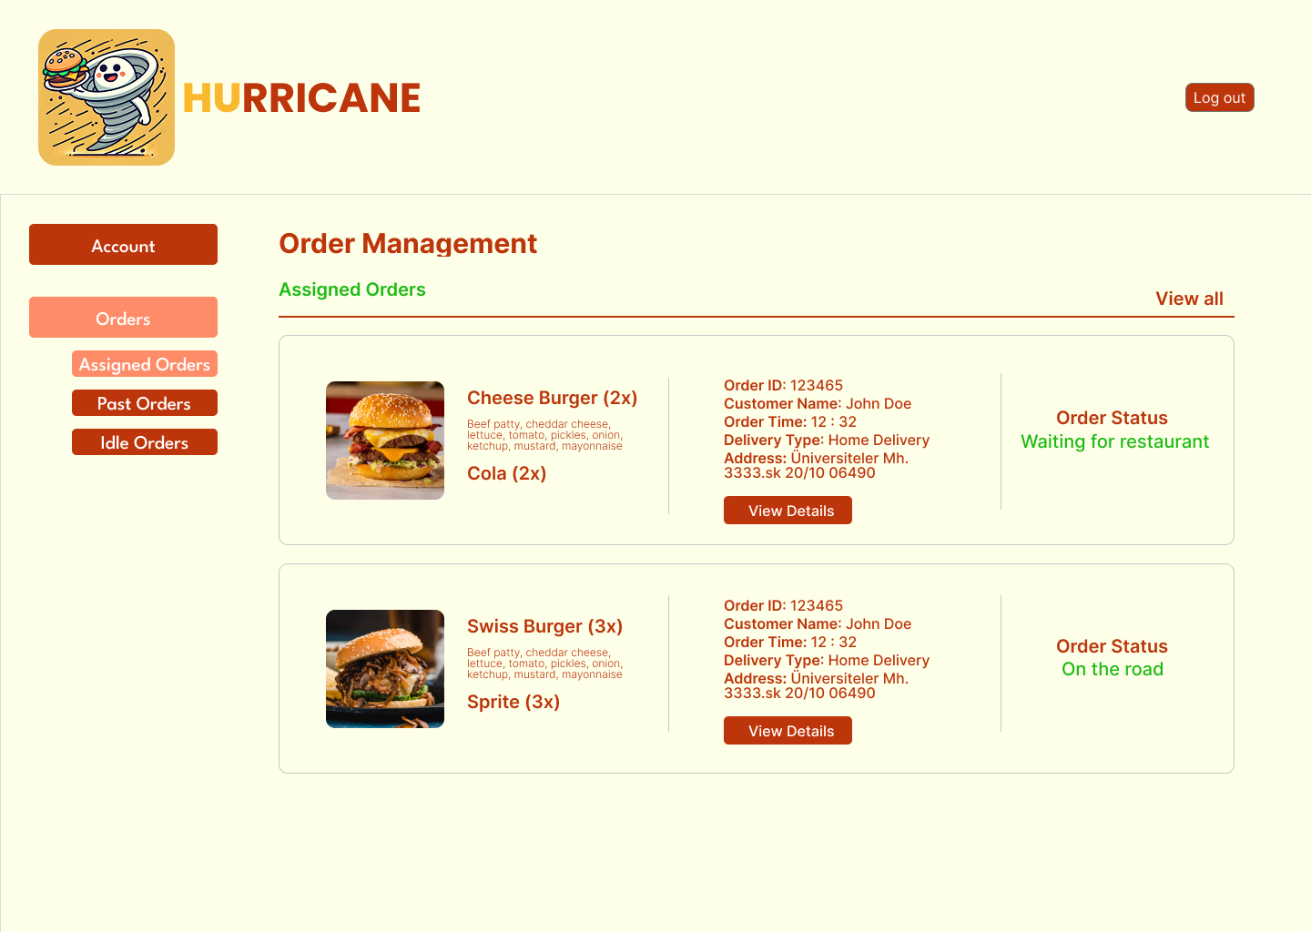

**User Interface/Report Number: Courier - Past Orders**

**Related Use-Case: 9, 25**



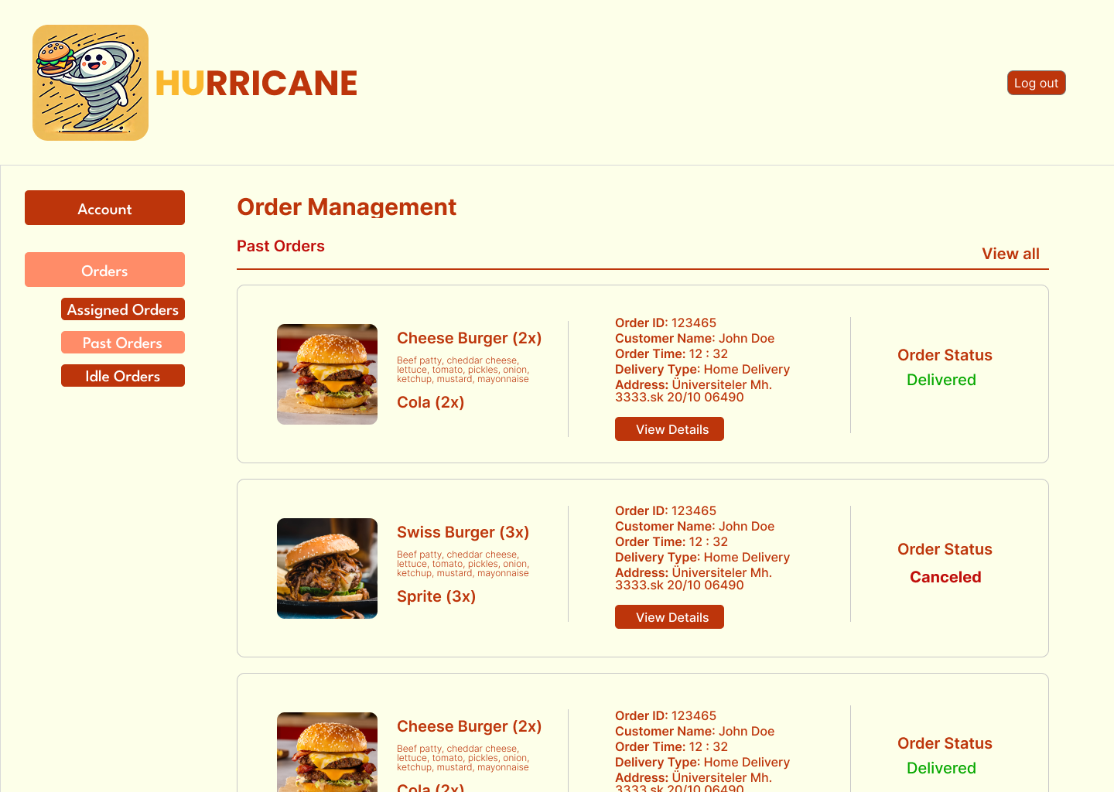

**User Interface/Report Number: Courier - Idle Orders**

**Related Use-Case: 9, 24**



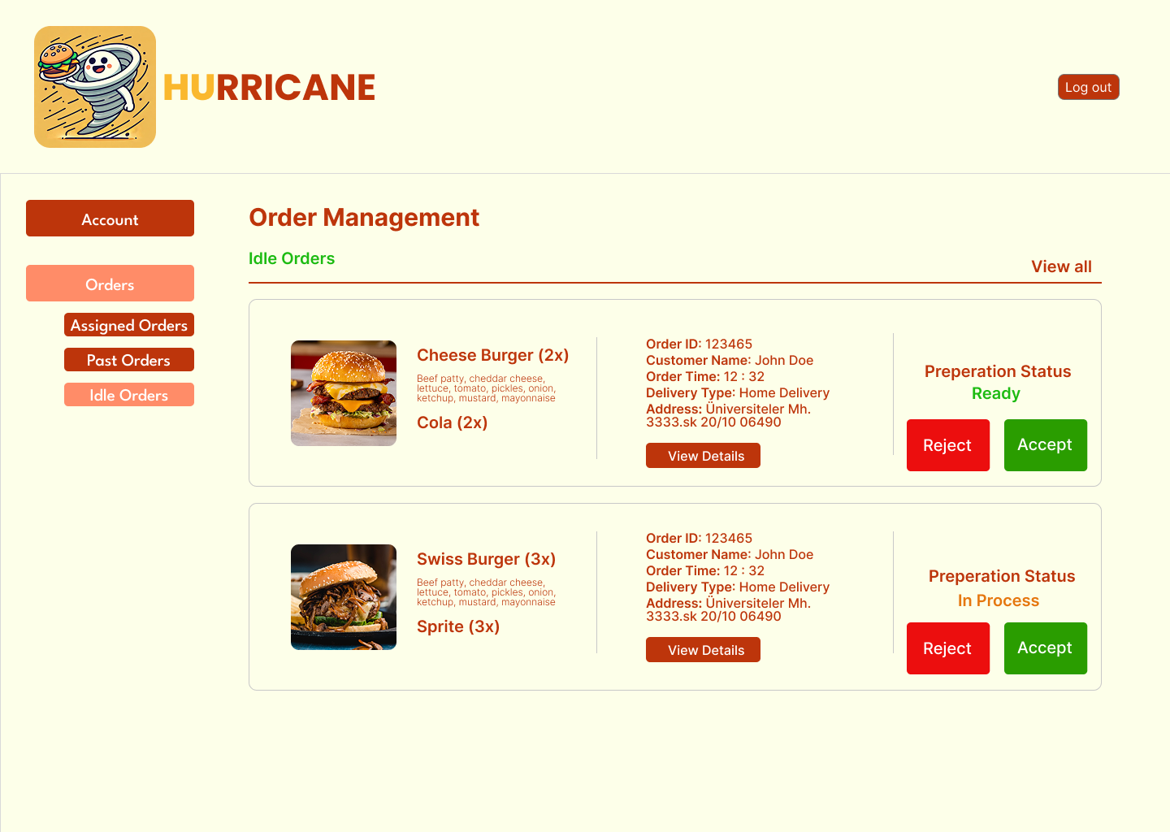

**User Interface/Report Number: Courier - Order Details**

**Related Use-Case: 9**



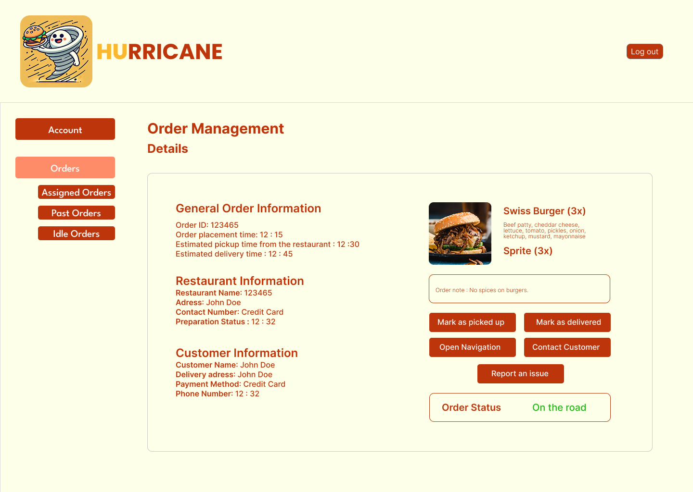

**User Interface/Report Number: Courier - Account Management Page**

**Related Use-Case: 9, 23**



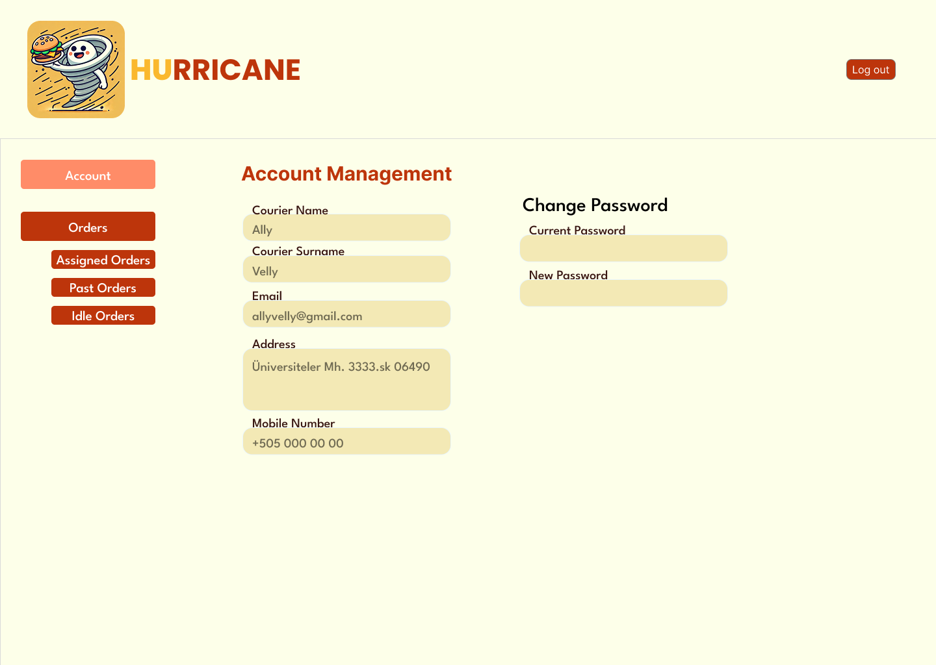

**User Interface/Report Number: Admin - Main Page**

**Related Use-Case: 14, 17, 26**



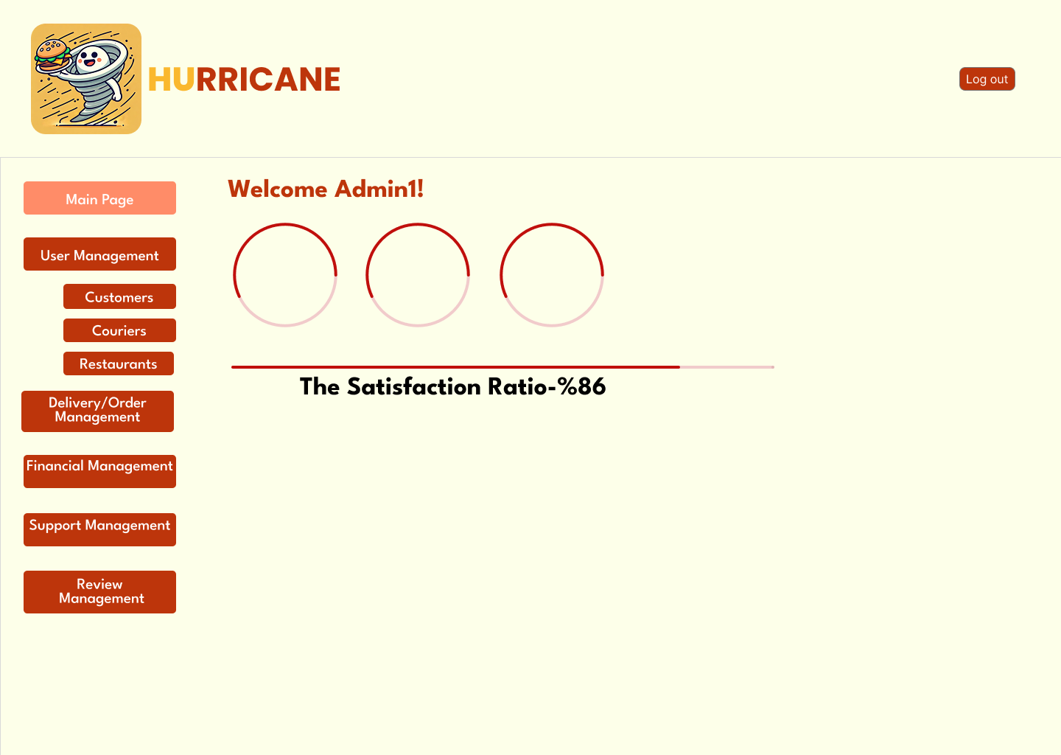

**User Interface/Report Number: Admin - Customer Management Page t**

**Related Use-Case: 14, 17, 19**



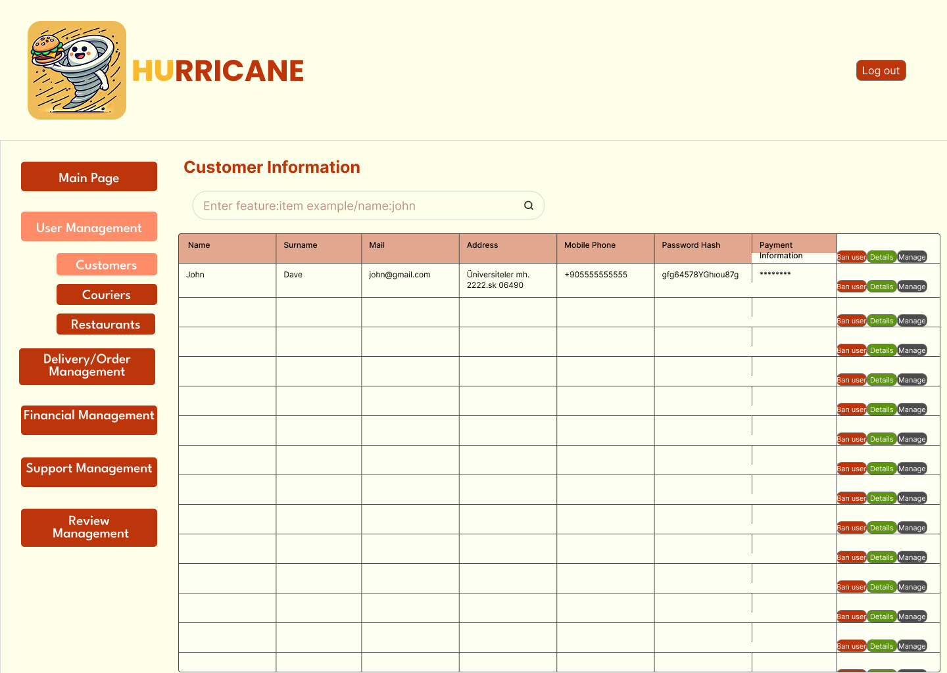

**User Interface/Report Number: Admin - Restaurants Management Page**

**Related Use-Case: 14, 19**



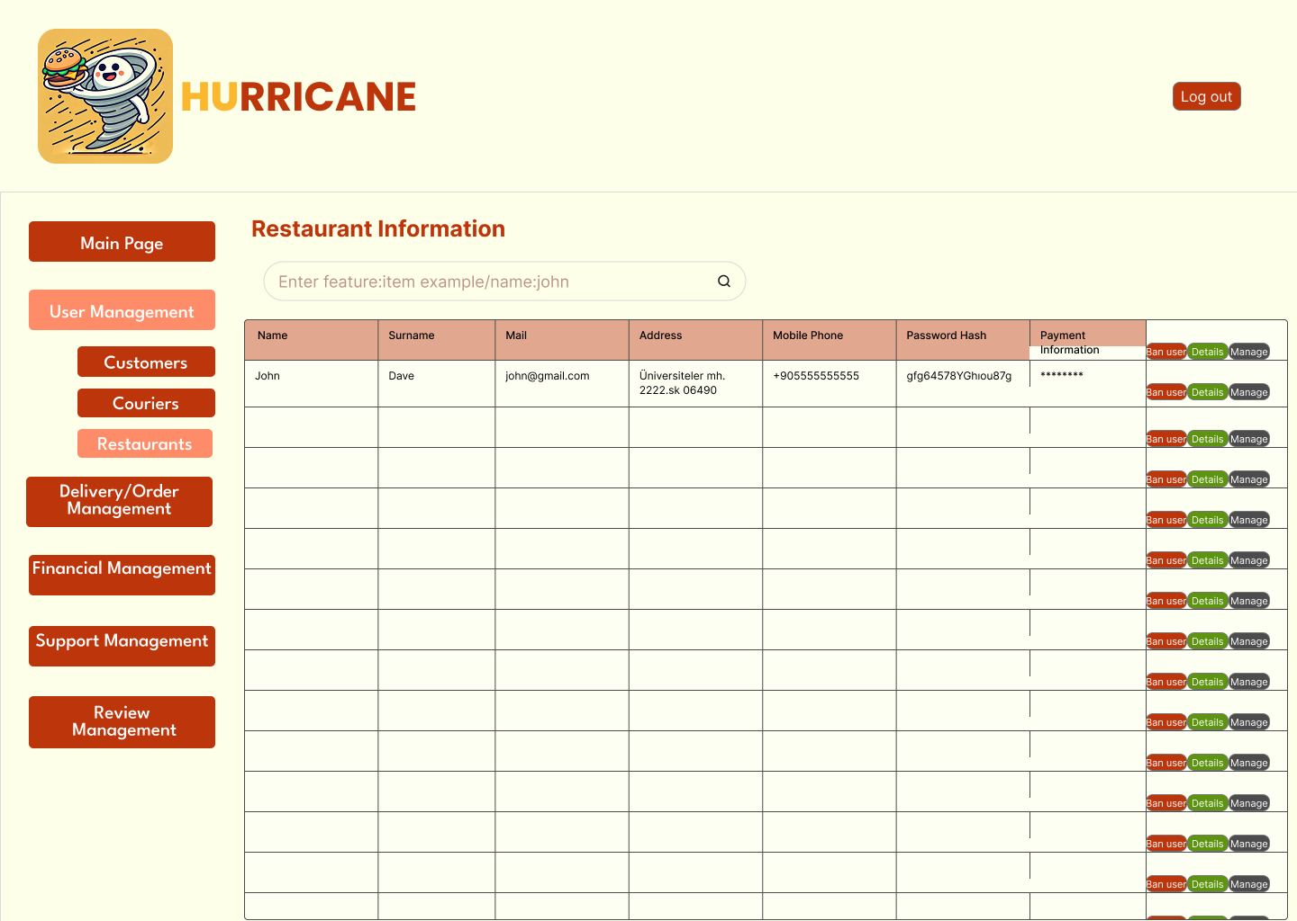

**User Interface/Report Number: Admin - Couriers Management Page**

**Related Use-Case: 14, 19, 24**



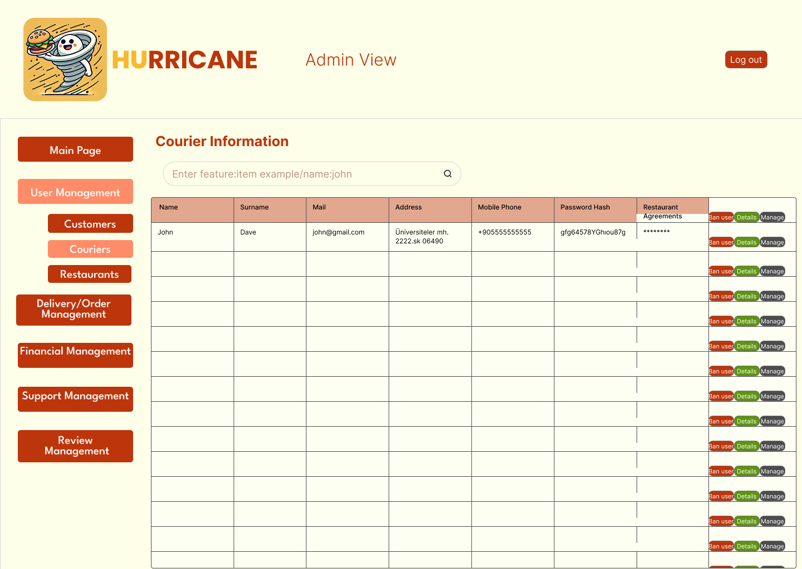

**User Interface/Report Number: Admin - Delivery Management Page**

**Related Use-Case: 14, 19, 20, 24, 25**



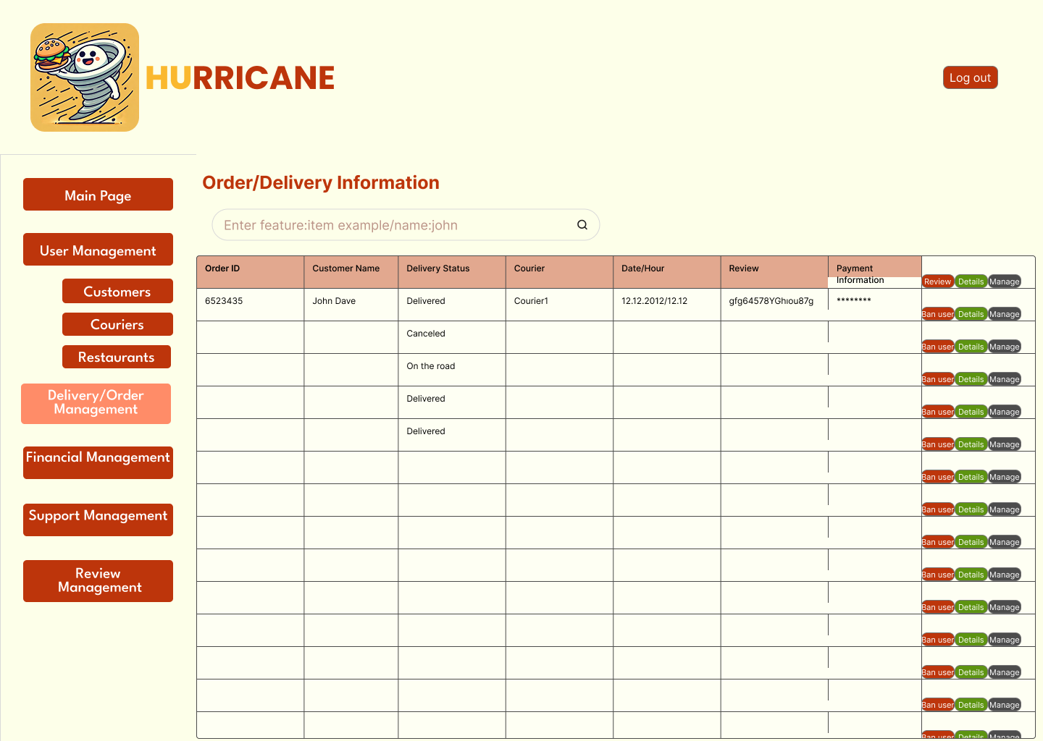

**User Interface/Report Number: Admin - Review Management Page**

**Related Use-Case: 14, 16**



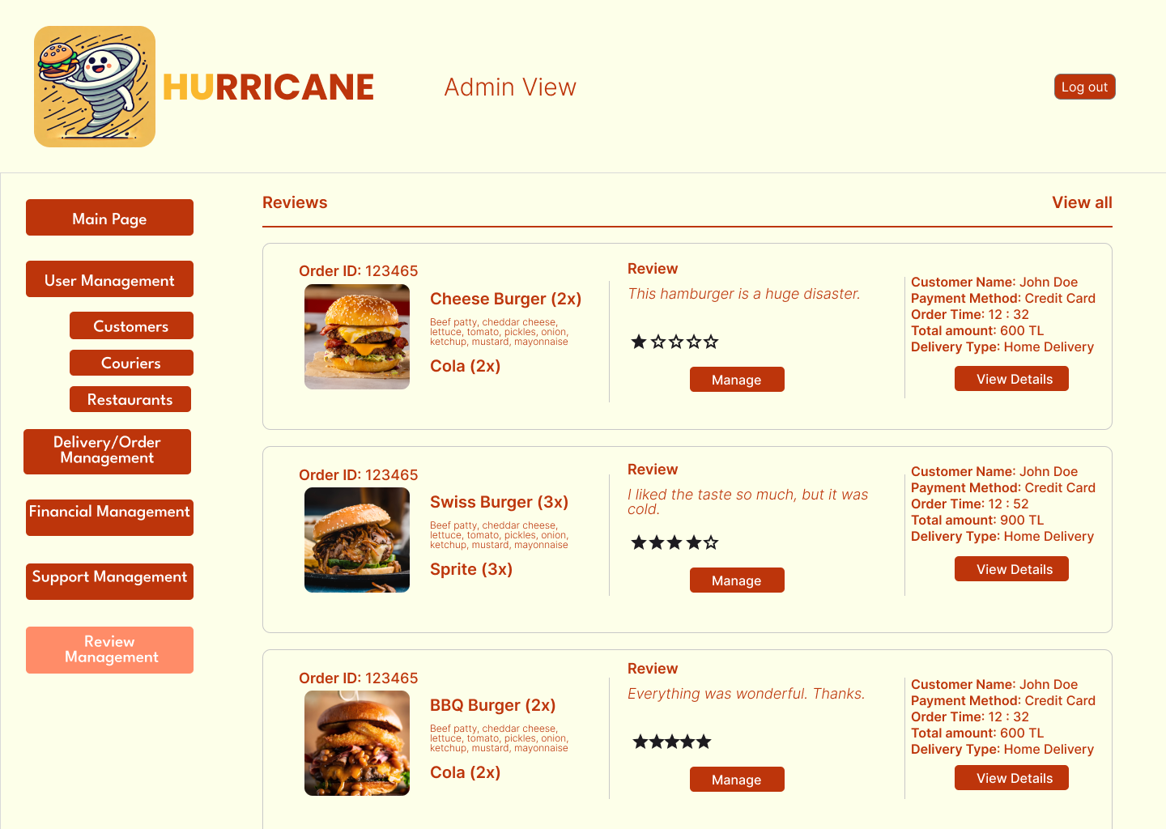

APPENDIX

We do not use generative AI or any other external sources, as we only implement the use case document.